Torturing Jesus For What is to Come
August 31st, 2021

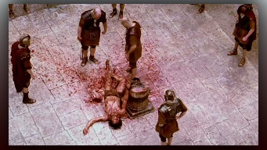
Mother Clare began, My dear family Jesus has suffered terribly this night August 11th, 2021.

This night I beheld the Lord being scourged, disemboweled and torn from limb to limb. It seemed to be happening in the basement of the Vatican, there were several of them in black cloaks and hoods with face masks and they were stretching His Body and breaking open his insides, like they did on the rack. But this was so strange, it was really taking place…how can that be? Did they take DNA from the shroud and clone his physical body? I do not understand what we were witnessing. Three of us were in the room with Ezekiel and we all saw it.

Very bloody. I looked and saw the Lord, totally bloody from head to toe. Chunks of flesh were hanging there all bloody. Oh Lord, we do not know the price You paid for our sins. Dear God forgive us.

Our Lady began, “Hold Him Clare. Comfort and support Him in your own arms. So very terrible is what has been planned. They don’t care how they reduce the population; they just want blood. But even that lust is never satisfied.” (Here Our Lady was talking about the torture they were putting Him through with their plans to reduce the population.)

Mother Mary continued, “My children nothing more horrible than this can be had on earth. Every indignation He was subjected to. Don’t you see the contrast? Here the actual creator of Heaven and Earth and His own do not recognize Him, but another. This is only the beginning of the final battle.

“Millions will die, millions. His Heart is in deep anguish and grief, He so needs our prayers. He is really suffering, more than you can imagine.”

Jesus began speaking, “This is the appointed time. This must come to pass. If you understood Clare the totality of what is going on there are so many more things you would understand, such as why you can’t see and hear more clearly. The static is enormous the airwaves are supercharged for what the earth is about to go through. Cleave to Me Clare, cleave to Me. Do not allow the circumstances to move you. Cleave to Me.”

